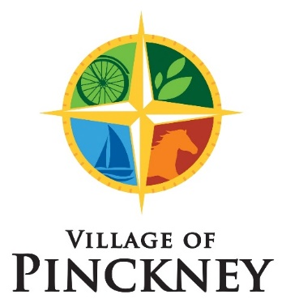
REGULAR COUNCIL MEETING
PROPOSED AGENDA

December 8, 2025 – 7:00 pm

CALL TO ORDER
ROLL CALL
PLEDGE OF ALLEGIANCE
PUBLIC FORUM

CONSENT AGENDA
- Agenda Approval
- Minutes Approval (of November 17 Regular Council Meeting)
- Bills Payable
- Financials
- Correspondence
- Approve Art in the Park and Food Truck Fridays event applications for 2026

VILLAGE MANAGER / VILLAGE PRESIDENT / ZONING ADMINISTRATOR REPORT
PUTNAM TOWNSHIP UPDATES
DEPARTMENT HEAD REPORTS

AGENDA:
- Audit Overview and Summary
- Correct Administrative Error Council Pay
- Resolution to pay for Water Meter Transceiver Units
- Welcome Holly Stebbens to Planning Commission
- Health Insurance Update
- DDA selling lot on Main St at Marion
- Updated Marijuana Scoring Rubric
- Revisit number of retail marijuana licenses
- Meeting dates for 2026

PUBLIC FORUM
COMMENTS/CONCERNS OF THE COUNCIL
ADJOURNMENT

Any person who addresses the Village Council during a council meeting of public forum shall be limited to five (5) minutes in length per individual presentation. The Village Clerk will maintain the official time and notify the speakers when their time is up.

